Name: Abdul Samad
Program: BSSE Group A – Semester 5th
Date: September 11, 2026
Lab Task 1

Ping Snippet
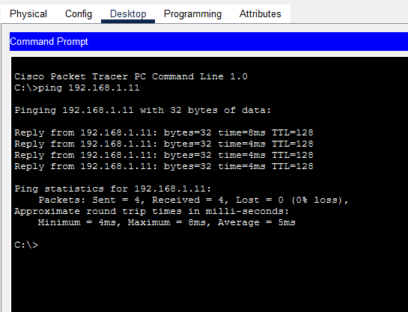

Simulation Snippet
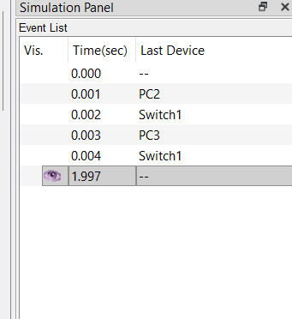

Topology Snippet
